**Heading:** Sprint 4 plan, MemLoc, Remind by Location, sprint completion date: 03.7, rev 1, 02/23/2022

Goal: Make the application smoother and fully functioning, by sending notifications and creating a clean interface.

**Task listing**

User story 1 : As a user, I want to receive notifications on my phone so that I do not have to check the website to see what is in the todo. (13 points)

1. Setup Twilio account (2 hours)
2. Add package and integrate with app (4 hours)
3. Write tests for twilio (3 hours) (6)
4. Write tests for backend functionality (3 hours) (7)
5. Attach coordinates to the task (1 hour) (3)
6. Send notifications based on location proximity (4 hours) (4)
7. Send notification based on time proximity (4 hours) (5)

User story 2: As a user, I want to be able to understand what the app is upon opening it and have an easy to use interface. (9 points)

1. Make sure that the inputting is all intuitive and clean (2 hours)
2. Add field in FE for phone number (2 hours)
3. Add a front/home page
4. Write tests for FE (3 hours)

**Team roles:**

Alexandra: Scrum Master, Frontend

Mythili: Frontend

Abirami: Frontend

Surya Rani: Backend

Case Delst: Product Owner, Backend, Frontend

Initial task assignment: A listing of each team member, with their first user story and task

assignment. This should look like:

Alexandra: Story 2: Task 1, 2 ,4

Mythili: Story 1: Task 1, 3

Abirami: Story 2, Tasks 2, 4

Surya Rani: Story 1: Task 4 ,5

Case Delst: Story 1, Task 4,6

Initial burnup chart: A graph giving the initial burnup chart for this sprint and is labeled as such

with sprint number and project name and is located in the lab.

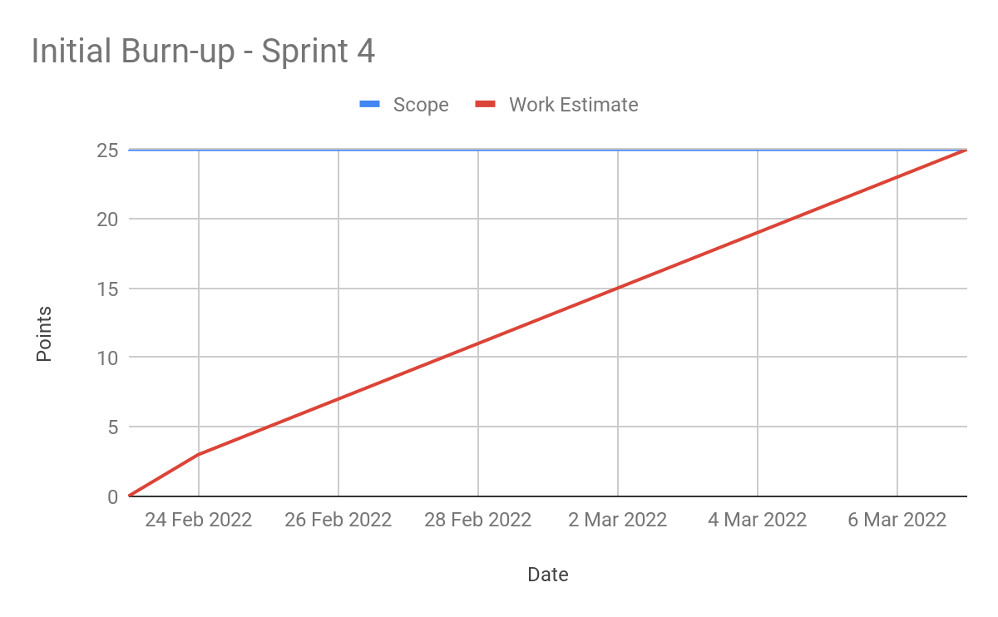

scrum board:

<https://trello.com/b/WOcwE1t6/memloc-s4>

Scrum times:

Monday/Wednesday/Friday @ 3pm

Meeting with TA Tuesday @ 3 pm